Final Year Project Proposal Report

Enabling Object Tracking in Mixed Reality
By:
Youssef SAADE, Ahmad HABIB

Supervisor(s):
Tony NICOLAS, Robin CHERIX, Omar ABOU KHALED

A report submitted in partial fulfillment of the requirements for the degree of
COMPUTER AND COMMUNICATIONS ENGINEERING

January 2026




École Supérieure d’Ingénieurs de Beyrouth Haute École d'Ingénierie et . Université Saint-Joseph de Beyrouth d'Architecture de Fribourg

Contents

List of figures 3
List of tables 4
Acronyms 5
Symbols 7
1 Introduction 8
2 Background Research and Related work 9
2.1 Object Detection and Tracking in Mixed Reality 9
2.2 Feature Detection and Scene Recognition 9
2.3 Camera Access for Real-Time Computer Vision 10
2.4 Positioning of Our Work 11
3 Requirements (Functional and Non-Functional Requirements) 11
3.1 Functional Requirements 11
3.2 Non-Functional Requirements: Encompassing measurable Quality Attributes, Constraints, Standards, and Regulations 11
3.3 Conceptual model 13
4 Solution Design 14
4.1 Propose multiple solutions: Design alternatives and comparison 14
4.2 Solution modeling 18
5 Preliminary implementation/tests 23
6 Conclusion and Future Work Planning 24
6.1 Conclusion 24
6.2 Project Timeline and Work Planning 25
6.3 Future Work and Extensions 25
7 References 27

List of figures

Figure 1 13
Figure 2 20
Figure 3 20
Figure 4 25

List of tables

Table 1 11
Table 2 12
Table 3 12

Acronyms

Acronym | Definition
2D | Two-Dimensional
3D | Three-Dimensional
6-DOF | Six Degrees of Freedom
ADB | Android Debug Bridge
AKAZE | Accelerated-KAZE (feature detector)
API | Application Programming Interface
AR | Augmented Reality
BRIEF | Binary Robust Independent Elementary Features
CNN | Convolutional Neural Network
CPU | Central Processing Unit
EHR | Electronic Health Records
FAST | Features from Accelerated Segment Test
FPS | Frames Per Second
GDPR | General Data Protection Regulation
GPU | Graphics Processing Unit
HIPAA | Health Insurance Portability and Accountability Act
MFA | Multi-Factor Authentication
MR | Mixed Reality
NDK | Native Development Kit
ORB | Oriented FAST and Rotated BRIEF
PnP | Perspective-n-Point
R-CNN | Region-Based Convolutional Neural Network
R-FCN | Region-Based Fully Convolutional Network
RAM | Random Access Memory
RANSAC | Random Sample Consensus
RGB | Red Green Blue
ROI | Region of Interest
SDK | Software Development Kit
SIFT | Scale-Invariant Feature Transform
SSD | Single Shot MultiBox Detector
SURF | Speeded Up Robust Features
UI | User Interface
UML | Unified Modeling Language
USB | Universal Serial Bus
VR | Virtual Reality
XR | Extended Reality

Symbols

Symbol | Definition
f | Focal length of camera (in pixels)
K | Camera intrinsic matrix
R | Rotation matrix (3x3)
t | Translation vector (3x1)
θ | Rotation angle (in degrees or radians)
Δt | Time interval or latency (in milliseconds)
ε | Error or tolerance threshold
σ | Standard deviation
α | Smoothing factor for filtering (0 to 1)
P | Pose (position and orientation) of object
n | Number of feature points or iterations
d | Distance or displacement (in centimeters)

Introduction
Virtual Reality (VR) and Mixed Reality (MR) technologies have reached a high level of visual realism. However, enabling realistic physical interaction with virtual environments remains a major challenge. One promising solution to this problem is passive haptics, which consists of aligning a real physical object with its virtual representation, allowing users to touch a real object while seeing its virtual counterpart.
Current passive haptics systems usually rely on external cameras, markers, and complex calibration processes, which increase system cost and reduce portability. Recently, Meta introduced the Passthrough API for the Meta Quest 3 headset, providing real-time access to onboard camera streams. This opens new possibilities for object tracking directly from the headset without additional hardware.
The scope of this project is to design and implement a real-time object tracking module in Unity3D that uses the Meta Quest 3 Passthrough API to track the position and orientation of a real object and align it with a virtual object in a mixed reality environment.
This project is important as it contributes to improving realism and immersion in MR applications while reducing system complexity. Potential beneficiaries include researchers, developers, educational institutions, and industries working in VR/MR interaction, training, simulation, and learning environments.
The main objective is to enable accurate and stable real-object tracking using only onboard sensors. This will be achieved through computer vision techniques, pose estimation algorithms, and real-time integration within the Unity engine.
Key challenges include limited computational resources on the headset, access restrictions to camera data, and real-time performance constraints. These challenges will be addressed through algorithm optimization, modular system design, and iterative testing.
The final deliverables include a functional prototype, technical documentation, and performance evaluation results, developed in collaboration with the Human Tech Institute at HEIA Fribourg

Background Research and Related work

2.1 Object Detection and Tracking in Mixed Reality

Object detection and tracking in Mixed Reality (MR) environments has received growing attention with the emergence of head-mounted displays such as Microsoft HoloLens and Meta Quest. One of the main challenges in MR systems is achieving real-time performance despite limited on-device computational resources.
Farasin et al. present a real-time MR system for object detection and tracking using Microsoft HoloLens, relying on a hybrid cloud–local architecture [1]. In their approach, computationally expensive deep learning models, including Faster R-CNN, R-FCN, and SSD, are executed on a remote cloud server equipped with GPU resources, while lightweight tracking algorithms are executed directly on the headset. This design allows the system to satisfy real-time constraints while maintaining acceptable detection accuracy.
To further reduce latency and network overhead, the authors introduce a detection policy that dynamically decides whether to perform cloud-based object detection or rely on local tracking. This decision is based on user motion, scene stability, and object visibility. Experimental results show a significant reduction in cloud detection requests and an increase in frame processing rate, demonstrating the effectiveness of combining cloud-based detection with on-device tracking [1].
This work is highly relevant to our project, as it validates the feasibility of distributed MR tracking pipelines and highlights the importance of minimizing costly detection operations in real-time MR applications.

2.2 Feature Detection and Scene Recognition

Feature detection and matching are fundamental components of many computer vision applications, including object recognition, scene understanding, and tracking. Feature-based approaches aim to identify distinctive and repeatable keypoints that can be matched across different images or viewpoints.

ORB (Oriented FAST and Rotated BRIEF) has been proposed as a fast and efficient alternative to traditional feature detectors such as SIFT and SURF, which are computationally expensive and less suitable for real-time applications on constrained devices [2]. ORB combines the FAST keypoint detector with the BRIEF descriptor while introducing orientation invariance, making it well adapted to real-time vision systems.

In MR applications, feature detection can be used to recognize previously observed scenes and determine whether a new object detection step is required. By comparing feature descriptors across frames, the system can avoid redundant processing and reduce unnecessary calls to heavy detection algorithms. Due to its efficiency and robustness, ORB is particularly suitable for scene recognition and tracking support in Mixed Reality environments [2].

2.3 Camera Access for Real-Time Computer Vision
Efficient and low-latency access to camera data is essential for real-time object tracking systems. On Android-based platforms, the Camera2 API provides a low-level interface for controlling camera devices and capturing continuous image streams with configurable resolution, format, and frame rate [3]. Its pipeline-based design allows multiple capture requests to be processed simultaneously, enabling high frame rates required by computer vision applications.

Building on this foundation, Meta introduced the Passthrough Camera API for Quest headsets, which extends the Android Camera2 API to support computer vision and machine learning workloads in Mixed Reality environments [4]. This API provides direct access to forward-facing RGB cameras, enabling applications to perform object detection, tracking, and environment understanding using real-world visual input.

The Passthrough Camera API is explicitly designed for computer vision and machine learning use cases, offering low-latency image capture and high refresh rates suitable for real-time processing. In practice, this corresponds to camera streams operating at frame rates up to approximately 60 frames per second, with end-to-end capture-to-availability latency on the order of tens of milliseconds, depending on the selected resolution and processing pipeline.

For real-time object tracking, the system typically operates on downscaled RGB frames (e.g., 640×480 or 720p) rather than full camera resolution, which significantly reduces processing time while preserving sufficient visual detail for feature detection and marker tracking. These characteristics enable continuous perception of the physical environment with minimal delay, which is essential for stable object tracking and user comfort in Mixed Reality applications [4].

2.4 Positioning of Our Work
Previous studies show that real-time object detection and tracking in Mixed Reality require careful trade-offs between accuracy, latency, and computational cost. Hybrid cloud–local architectures, lightweight tracking algorithms, and efficient feature-based scene recognition techniques are commonly adopted to overcome hardware limitations [1], [2].

Building upon these contributions, our work focuses on designing a real-time object tracking system for Mixed Reality that leverages efficient camera access mechanisms and lightweight vision techniques, while minimizing computational overhead and latency. Our approach aligns with existing best practices and adapts them to the specific constraints and objectives of a standalone Mixed Reality object tracking application running on the Meta Quest 3 headset.
2.5 Hardware Platform Analysis

The target hardware platform for this project is the Meta Quest 3 mixed reality headset. The device is based on a mobile system-on-chip architecture and is capable of operating in two distinct modes: standalone mode and tethered (Link) mode.
In standalone mode, all computation—including computer vision processing, pose estimation, and rendering—is executed directly on the headset. This mode offers maximum portability and independence from external hardware but imposes strict constraints on computational resources, power consumption, and thermal limits.
In tethered mode (Meta Quest Link), the headset acts primarily as a display and sensor interface, while rendering and application logic are executed on an external computer. In this configuration, the Mixed Reality application runs on the PC, and rendered frames are streamed to the headset. Although this mode provides access to significantly higher CPU and GPU resources, it introduces additional latency due to video encoding, transmission, and decoding, and limits mobility.
For this project, the primary focus is on the standalone mode, as it represents the most constrained and challenging scenario for real-time object tracking. Designing the system to operate efficiently under these limitations ensures portability, offline operation, and independence from external infrastructure. However, the tethered mode remains relevant for future extensions or experimental setups requiring heavier computation.

Requirements (Functional and Non-Functional Requirements)

Functional Requirements
Table 1
ID | Functional Requirement
FR1 | The system shall access the camera stream via the Meta Quest Passthrough API
FR2 | The system shall detect a predefined real object in the camera feed
FR3 | The system shall estimate the 3D position of the object
FR4 | The system shall estimate the 3D orientation of the object
FR5 | The system shall update the virtual object’s transform in Unity in real time
FR6 | The system shall maintain alignment during user head movement
FR7 | The system shall allow reinitialization of tracking if tracking is lost

Non-Functional Requirements: Encompassing measurable Quality Attributes, Constraints, Standards, and Regulations

Quality attributes and technical constraints

Table 2
ID | Non-Functional Requirement
NFR1 | The system shall run at a minimum of 60 FPS
NFR2 | End-to-end tracking latency shall not exceed 50 ms
NFR3 | Position tracking error shall be ≤ 2 cm
NFR4 | Orientation tracking error shall be ≤ 5 degrees
NFR5 | Tracking shall remain stable for at least 30 seconds without reinitialization
NFR6 | CPU and GPU utilization shall not exceed 80%
NFR7 | Tracking recovery after occlusion shall occur within 1 second
NFR8 | The system shall operate continuously for 10 minutes without failure

Standards, Laws and Regulations

Table 3
Name of standard | Part/Section # | Part/Section Title | Brief Description how your solution is compliant to this
GDPR | Art. 5 | Data minimization | No personal data is stored
ISO/IEC 27001 | A.12.4.1 | Logging & monitoring | Application logs system events
IEEE 12207 | 6.4.11 | Software Validation Process | Unit and integration tests are applied
UML | – | System modeling | UML diagrams used for design

Conceptual model
The conceptual model of the proposed system describes the main entities involved in the object tracking process and the interactions between them.
At a high level, the system consists of four main components: the Passthrough Camera Module, the Vision Processing Module, the Pose Estimation Module, and the Unity Integration Module.
The Passthrough Camera Module is responsible for acquiring real-time RGB frames from the Meta Quest 3 headset using the Passthrough API. These frames represent the user’s physical environment and serve as the primary input to the system.
The Vision Processing Module analyzes the camera frames to detect and track the target real-world object. This module extracts visual features from the image stream and monitors changes across frames to maintain object correspondence over time.
The Pose Estimation Module computes the 3D position and orientation of the tracked object relative to the headset coordinate system. This information is continuously updated to account for user head movement and object motion.
Finally, the Unity Integration Module maps the estimated pose of the real object to a virtual object inside the Unity3D environment. This ensures that the virtual object remains spatially aligned with its real counterpart, enabling a coherent mixed reality experience.
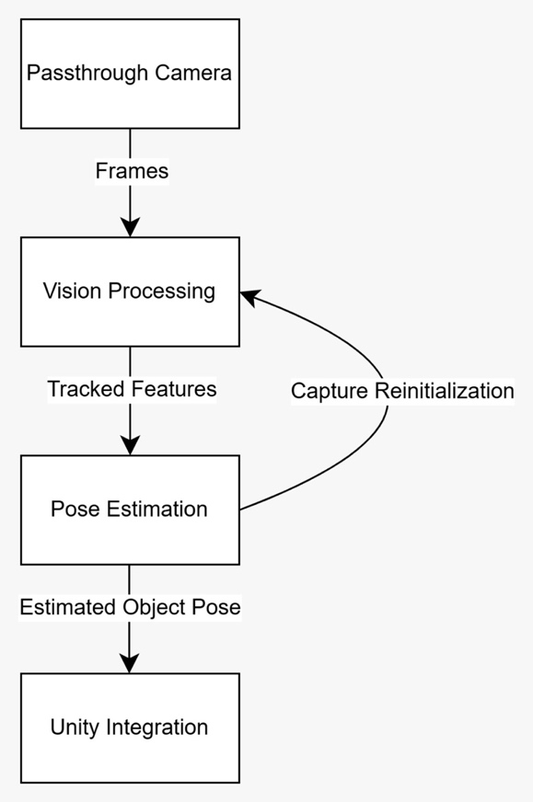
Data flows sequentially from camera acquisition to pose estimation, while feedback loops allow reinitialization when tracking confidence decreases or tracking is lost.
Figure 1

Solution Design

This section presents the design approach for implementing object tracking in Mixed Reality using the Meta Quest 3 headset. Multiple architectural alternatives are evaluated, followed by detailed modeling of the selected solution.

Propose multiple solutions: Design alternatives and comparison
There is no single optimal solution for object tracking in mixed reality. Several design alternatives were considered at both high and low levels.

High level alternatives
At the architectural level, three main approaches were evaluated for implementing object tracking in the Meta Quest 3 environment:

Alternative 1: Fully On-Device Processing

In this approach, all computer vision processing, including feature detection, matching, and pose estimation, is performed entirely on the Meta Quest 3 headset. The system leverages the Passthrough API to access camera frames, processes them using optimized algorithms running within Unity, and updates the virtual object pose in real-time.
Advantages:
- No network latency - immediate response to object movement
- Works offline without internet connectivity
- Privacy-preserving - no camera data leaves the device
- Simpler system architecture with fewer dependencies
Disadvantages:
- Limited computational resources on mobile hardware
- Battery consumption concerns for extended use
- Requires careful optimization to achieve real-time performance

Alternative 2: Hybrid Cloud-Device Architecture
This approach distributes processing between the headset and a remote server. Computationally expensive operations such as deep learning-based object detection are offloaded to a cloud server with GPU resources, while lightweight tracking algorithms run locally on the device. The headset sends camera frames to the server periodically for object detection, then performs frame-to-frame tracking locally between detection requests.
Advantages:
- Access to powerful GPU processing for complex algorithms
- Can leverage state-of-the-art deep learning models
- Reduces battery consumption on the headset
Disadvantages:
- Introduces network latency that may affect user experience
- Requires reliable internet connection
- Privacy concerns with transmitting camera data
- Added complexity in system architecture and deployment

Alternative 3: Marker-Based Tracking with Passthrough
This approach uses fiducial markers (such as ArUco or AprilTags) attached to the target object. The system detects these markers in the Passthrough camera feed and computes the object pose based on the known marker geometry. This is a well-established technique with robust libraries available.
Advantages:
- Very accurate pose estimation
- Computationally efficient detection
- Robust to lighting variations
- Mature libraries and well-documented techniques
Disadvantages:
- Requires physical modification of the object (adding markers)
- Less immersive - markers may be visible to the user
- Limited to objects that can accommodate markers

Alternative 4: Tethered Execution using Meta Quest Link
In this configuration, the Meta Quest 3 headset is connected to a personal computer using Meta Quest Link. The Mixed Reality application runs entirely on the PC, where both rendering and computer vision processing are executed using the PC’s CPU and GPU resources. The resulting rendered frames are then streamed to the headset, which acts as a display and tracking interface.
.Advantages:
• Access to significantly higher computational power • Easier integration of complex computer vision or deep learning algorithms • Reduced on-device processing load
Disadvantages:

• Additional latency introduced by video encoding and streaming • Reduced portability due to physical tethering • Dependence on a powerful external computer
Positioning:
While this configuration enables more computationally intensive processing, it is not selected as the primary solution for this project, as it does not represent a fully standalone Mixed Reality system. The project instead prioritizes on-device processing to ensure portability, offline operation, and realistic deployment conditions.

Low level alternatives

Within the selected high-level architecture, several component-level design decisions were evaluated:
Computer Vision Library Selection
Three main options were considered for implementing computer vision algorithms:
- OpenCV for Unity: The most comprehensive computer vision library, offering extensive functionality including feature detection (ORB, SIFT, SURF), pose estimation, and ArUco marker detection. However, it has a larger footprint and requires careful optimization for mobile platforms.
- Vuforia Engine: Commercial SDK optimized for AR/MR tracking with built-in object recognition and tracking capabilities. Offers excellent performance but requires licensing and provides less flexibility for custom implementations.
- Custom Implementation: Building lightweight feature detection and tracking from scratch using Unity's computational capabilities. Provides maximum control but requires significant development time.

Selected: OpenCV for Unity was chosen for its comprehensive feature set, active community support, and proven track record in similar applications. The ability to use ArUco markers as a fallback tracking method was particularly valuable.
Feature Detection Algorithm
For markerless tracking scenarios, the choice of feature detector significantly impacts performance:
- ORB (Oriented FAST and Rotated BRIEF): Fast, rotation-invariant feature detector well-suited for real-time applications. Performs adequately on textured objects but may struggle with uniform surfaces.
- SIFT (Scale-Invariant Feature Transform): More robust and accurate than ORB, especially for scale changes. However, it is computationally expensive and may not achieve real-time performance on the Quest 3.
- AKAZE: Provides a balance between ORB and SIFT, offering good performance with acceptable computational cost.
Selected: ORB was chosen as the primary feature detector due to its speed and adequate performance for the target use case. AKAZE will be evaluated as an alternative if tracking quality proves insufficient.
Pose Estimation Method
Two approaches were considered for estimating 3D pose from 2D image features:
- PnP (Perspective-n-Point): Solves for camera pose given a set of 3D-2D point correspondences. Requires prior knowledge of the object's 3D model but provides accurate pose estimates.
- Homography-based: Estimates pose assuming the object surface is planar. Computationally simpler but limited to flat objects or object faces.
Selected: PnP with RANSAC for outlier rejection was selected as it provides robust 6-DOF pose estimation and can handle both planar and non-planar objects. For marker-based tracking, the built-in ArUco pose estimation will be used.
Tracking Strategy
The temporal tracking strategy determines how the system maintains object correspondence across frames:
- Detection-per-frame: Perform full object detection every frame. Most robust but computationally expensive.
- Detection-then-tracking: Detect the object initially, then use lightweight optical flow or feature matching for subsequent frames. Re-detect when tracking confidence drops.
- Predictive tracking: Use Kalman filtering or similar techniques to predict object motion and reduce search space.
Selected: A detection-then-tracking approach with predictive elements will be implemented. This balances performance with robustness and allows recovery from temporary tracking failures.

Solution modeling
Based on the selected alternatives, this section presents the detailed design of the chosen solution. The system architecture consists of four main modules integrated within Unity3D, communicating through well-defined interfaces.

Diagrams and flowcharts
The system follows a modular pipeline architecture with the following components:
1. Passthrough Camera Module
Responsibilities:
- Interface with Meta Quest 3 Passthrough API
- Acquire RGB camera frames at 60 FPS
- Convert frame format to OpenCV-compatible format
- Handle camera calibration parameters
Implementation Details:
- Uses OVRPassthroughLayer for camera access
- Implements frame buffering to prevent data loss
- Provides timestamps for frame synchronization
2. Vision Processing Module
Responsibilities:
- Detect ArUco markers or extract ORB features
- Match features between reference and current frame
- Filter outliers using geometric constraints
- Maintain feature database for tracking
Implementation Details:
- Two parallel tracking modes: marker-based (primary) and feature-based (fallback)
- Adaptive feature detection threshold based on frame quality
- Brute-force matcher with cross-check for feature correspondence
- Region of interest (ROI) definition to reduce processing area
3. Pose Estimation Module
Responsibilities:
- Compute 6-DOF pose (position and orientation) from matched features
- Apply RANSAC for robust estimation
- Implement Kalman filter for pose smoothing
- Detect and handle tracking failures
Implementation Details:
- Uses solvePnPRansac for robust pose estimation
- Confidence score based on inlier ratio and reprojection error
- Exponential smoothing filter to reduce jitter
- Coordinate transformation from camera space to Unity world space
4. Unity Integration Module
Responsibilities:
- Update virtual object transform based on estimated pose
- Manage tracking state machine (initializing, tracking, lost)
- Provide debugging visualization and telemetry
- Handle user interaction for tracking initialization
Implementation Details:
- MonoBehaviour component attached to tracked GameObject
- Interpolation for smooth updates between tracking frames
- Debug overlay showing tracking confidence and FPS
- Event system for tracking state changes
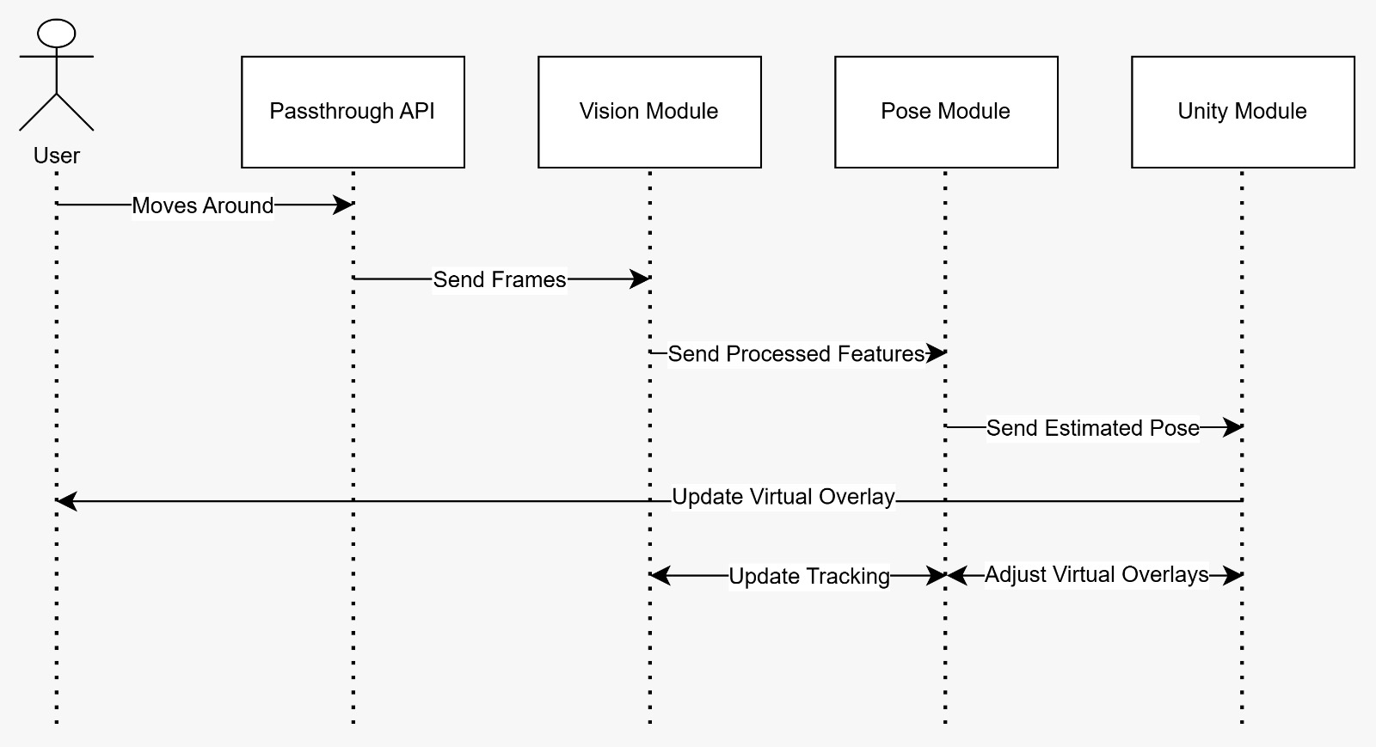
Figure 2

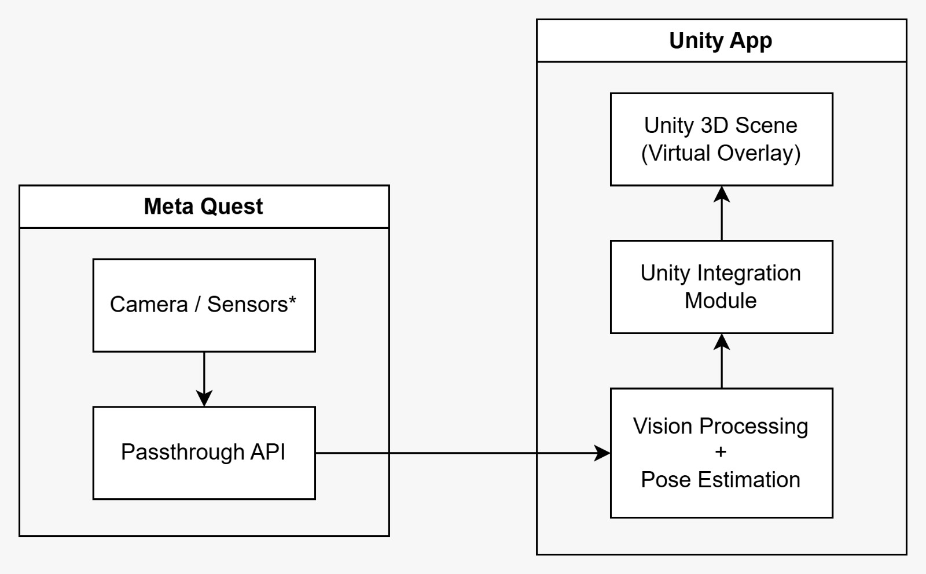
Figure 3

Key Algorithms and Techniques

ArUco Marker Detection:
The primary tracking method uses ArUco markers, which are square fiducial markers with unique binary patterns. The detection process identifies marker corners in the image, decodes the marker ID, and computes the pose using the known marker size. This provides robust and accurate 6-DOF pose estimation with minimal computational overhead.
ORB Feature Matching:
For scenarios where markers cannot be used, ORB features are extracted from the object surface during initialization. These features are matched against subsequent frames using a brute-force matcher with Hamming distance. Geometric verification using RANSAC filters spurious matches before pose estimation.
Pose Filtering:
To reduce tracking jitter and improve stability, estimated poses are filtered using an exponential smoothing filter. The smoothing factor is dynamically adjusted based on tracking confidence - higher confidence allows more aggressive smoothing, while lower confidence reduces smoothing to remain responsive to actual object movement.
Coordinate System Transformation:
The camera coordinate system (OpenCV convention) differs from Unity's coordinate system. A transformation matrix is applied to convert the estimated pose from camera space to Unity world space, accounting for differences in axis orientation and the headset's position in the scene.

Required Resources

The following hardware and software resources are required for implementing the proposed solution:
Hardware:
- Meta Quest 3 or Quest 3S headset with Passthrough API support
- Development PC (Windows 10/11 with at least 16GB RAM, GPU recommended)
- USB-C cable for device debugging and deployment
- Physical objects for testing (with ArUco markers or textured surfaces)
Software:
- Unity 6.3 LTS or later
- Oculus Integration SDK for Unity
- OpenCV for Unity (asset from Unity Asset Store or compiled library)
- Git for version control
- Visual Studio or JetBrains Rider for C# development
Development Tools:
- Meta Quest Developer Hub for device management
- Unity Profiler for performance analysis
- RenderDoc or similar graphics debugging tool
Libraries and Dependencies:
- OpenCV 4.x (computer vision algorithms)
- ArUco marker detection module
- Unity XR Plugin Management
- Oculus XR Plugin

Performance Considerations

Meeting the non-functional requirements, particularly the 60 FPS target and low latency, requires careful performance optimization:
- Frame Processing Budget: At 60 FPS, each frame has approximately 16.7ms for processing. The vision processing and pose estimation must complete within 10-12ms to leave time for Unity rendering.
- Resolution Trade-off: Processing will be performed on downscaled camera frames (e.g., 640x480 instead of full resolution) to reduce computational load while maintaining adequate tracking accuracy.
- Multithreading: Vision processing will run on a separate thread to avoid blocking the main Unity thread. Pose updates will be synchronized using thread-safe queues.
- Adaptive Quality: The system will dynamically adjust processing parameters (number of features, search region size) based on available computational headroom.
- Memory Management: Object pooling and careful memory allocation strategies will be employed to avoid garbage collection pauses that could disrupt real-time performance.

Error Handling and Robustness

The system implements multiple layers of error handling to ensure robust operation:
- Tracking Confidence Monitoring: A confidence score is computed based on the number of matched features and reprojection error. When confidence drops below a threshold, the system enters a cautious mode with increased detection frequency.
- Graceful Degradation: If marker detection fails, the system falls back to feature-based tracking. If both methods fail, the virtual object's last known pose is maintained with a visual indicator of tracking loss.
- Occlusion Handling: When the object is temporarily occluded, motion prediction maintains approximate pose for up to 1 second before requiring re-detection.
- User Feedback: Visual and haptic feedback inform the user of tracking status, initialization requirements, and system errors.

Preliminary implementation/tests

Initial work has focused on setting up the development environment and validating technical feasibility.
5.1 Preliminary Implementation
• Unity project configuration for Meta Quest 3
• Integration of Passthrough API
• Basic camera feed visualization in mixed reality
• Initial object detection experiments

5.2 Preliminary Testing
• Frame rate measurement
• Latency observation
• Stability testing during head movement

These preliminary results confirm the feasibility of the proposed solution and guide future optimizations.

Version control and configuration management are handled using Git, ensuring traceability and controlled evolution of the codebase.

Conclusion and Future Work Planning

Conclusion
This proposal has presented a comprehensive plan for developing an object tracking module for Mixed Reality applications on the Meta Quest 3 headset. The project addresses a critical challenge in MR interaction: enabling realistic haptic feedback through passive haptics by accurately tracking real-world objects and aligning them with their virtual counterparts.
Through extensive background research, we have established the feasibility of the proposed approach. Prior work, particularly the hybrid cloud-local architecture demonstrated by Farasin et al., validates the concept of real-time object tracking in MR environments under computational constraints. Our solution builds upon these foundations while leveraging the recently available Passthrough API, eliminating the need for external cameras and complex calibration processes that have traditionally limited the portability of passive haptics systems.
The requirements analysis has defined clear functional and non-functional targets for the system. Key performance metrics include maintaining 60 FPS operation with sub-50ms latency, achieving position accuracy within 2 cm and orientation accuracy within 5 degrees, and ensuring robust tracking under realistic usage conditions. These requirements are ambitious yet achievable given the selected architectural approach and the capabilities of the Meta Quest 3 hardware.
The solution design phase evaluated multiple architectural alternatives at both high and low levels. The selected approach—fully on-device processing with marker-based tracking as the primary method and feature-based tracking as a fallback—offers the best balance between real-time performance, system simplicity, and implementation feasibility within the 4-month project timeline. This design prioritizes privacy by keeping all camera data on-device, eliminates network latency concerns, and maintains system portability by operating entirely offline.
The modular architecture, consisting of the Passthrough Camera Module, Vision Processing Module, Pose Estimation Module, and Unity Integration Module, provides a clear separation of concerns and facilitates incremental development and testing. Each module has well-defined responsibilities and interfaces, allowing for independent optimization and potential replacement of components as better algorithms or techniques become available.
Preliminary implementation work has already validated the technical feasibility of accessing camera data through the Passthrough API and integrating computer vision processing within the Unity environment. Initial performance measurements confirm that the Quest 3 hardware is capable of supporting real-time vision processing, though careful optimization will be necessary to meet all performance targets consistently.
The project is well-positioned to make meaningful contributions to the field of Mixed Reality interaction. By creating an accessible framework for object tracking that requires no external hardware, we lower the barrier to entry for researchers and developers exploring passive haptics and tangible interaction in MR. The deliverables—including a functional prototype, comprehensive documentation, and performance evaluation—will provide a solid foundation for future research and development in this area.

Project Timeline and Work Planning

GANTT CHART
Figure 4

Future Work and Extensions

While this project establishes a functional object tracking framework, numerous opportunities exist for future enhancement and extension:
Deep Learning Integration:
Future iterations could incorporate deep learning-based object detection and pose estimation. Recent advances in efficient neural networks for mobile devices (MobileNet, EfficientNet) could enable more robust tracking without external markers. This would support tracking arbitrary objects without preparation, significantly expanding the system's applicability.
Multi-Object Tracking:
The current design focuses on tracking a single object. Extending the system to simultaneously track multiple objects would enable more complex interaction scenarios, such as multi-handed manipulation or collaborative MR environments where multiple users interact with shared physical props.
Deformable Object Tracking:
The current approach assumes rigid objects. Supporting deformable or articulated objects (such as hands, cloth, or jointed tools) would require more sophisticated tracking algorithms but would dramatically expand the range of physical interactions possible in MR.
Semantic Understanding:
Integrating object recognition and semantic understanding would enable context-aware interactions. The system could automatically identify object types (cup, tool, controller) and adapt virtual overlays or interaction affordances accordingly.
Cross-Platform Support:
While this project targets the Meta Quest 3, the modular architecture could be adapted to other MR headsets with passthrough capabilities (e.g., Apple Vision Pro, Meta Quest Pro, or future devices). Developing platform-agnostic APIs would increase the framework's utility and adoption.
Advanced Haptic Integration:
Beyond passive haptics, the tracking system could be integrated with active haptic devices (vibration motors, force feedback gloves) to provide richer tactile feedback. This would create a more complete sensory experience by combining the realism of passive haptics with the versatility of active haptic rendering.
User Studies and Applications:
Comprehensive user studies could evaluate the effectiveness of the tracking system in real-world applications such as VR training simulations, rehabilitation exercises, educational demonstrations, or collaborative design reviews. Such studies would provide valuable insights into usability, limitations, and optimal design patterns for passive haptics in MR.
Open-Source Community Development:
Releasing the framework as an open-source Unity package could foster community contributions, accelerate improvements, and establish best practices for object tracking in MR. A vibrant developer community could extend the system in directions not initially anticipated and drive adoption across various application domains such as training, education, simulation, and interactive design.

References

[1] A. Farasin, F. Peciarolo, M. Grangetto, E. Gianaria, and P. Garza,
Real-time object detection and tracking in mixed reality using Microsoft HoloLens,
Proceedings of the 15th International Conference on Computer Vision Theory and Applications (VISAPP), 2020.
DOI: 10.5220/0008877901650172.

[2] D. Deep,
Introduction to Feature Detection and Matching, Medium, 2019.

[3] Google Developers,
Android Camera2 API Documentation, Android Developers, 2025.

[4] Meta,
Passthrough Camera API Overview, Meta Horizon OS Developers, 2025.

Statement on the Use of Generative AI

Generative AI tools were used during the development of this project for supportive purposes. ChatGPT was used to assist with the drafting, language refinement, and structural improvement of the written report. Claude was used to support code testing, debugging, and verification during the software development phase.
All system design decisions, technical choices, implementations, experiments, and final interpretations were conceived, validated, and approved by the authors. The responsibility for the content and results of this project remains entirely with the authors.

